Veterans Day Dress Down Fundraiser
November 9, 2018
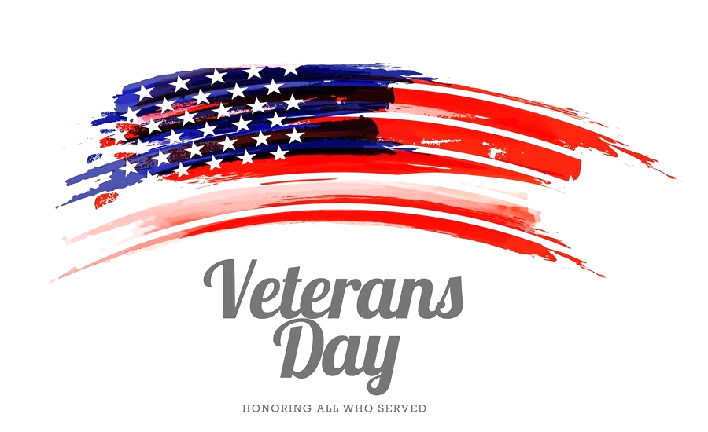

In Honor of those that have served, you may dress down on 11/9/2018 with the donation of $1 to go towards helping Homeless Veterans in St. Louis. When dressing down you may wear the colors of red, white, and/or blue with jeans. Please donate, we can use all the help we can get.
-Thank You

