Nov/Dec 2018
Monthly Happenings
Southwest Foodservice Excellence, LLC ~ “Putting Child Nutrition First”

At Premier Charter School in November and December…
- November and December were busy months for Premier Charter School and SFE. We had a lot of great activities going on in the school!
- On November 16th we had our annual Thanksgiving dinner featuring Turkey, Mashed Potatoes, Green Beans, Gravy and Pumpkin Mousse for dessert!
- Jorris Robinson, our Roving Chef, conducted Roving Chef classes on November. 14th and December 12th
  - We made Chicken and Vegetarian Taquitos with Cilantro Lime Rice in November
  - In December we made Chicken and Vegetarian Quesadillas with homemade Pico De Gallo.
- The fruit or veggie of the month
  - November - Cranberries – we featured cranberry relish with our Thanksgiving dinner.
  - December - Corn – we had Southwest Corn Salad – The students loved it!
- Try – it – Tuesdays
  - November - We had Egg and Cheese Breakfast Tacos with our breakfast for lunch day.
  - December – Homemade Chili with Cornbread – this was a hit!
- On December 19th, SFE conducted a taste test with the students. The students sampled our new Flapjack Pancake concept. We tried pancakes with freshly made Strawberry Compote and Apple Cinnamon Compote – Strawberry was the standout favorite!
- In December we started new salad bar items, which include: cauliflower, black olives, red and green peppers, squash and zucchini, mushrooms and sliced tomatoes. These will be rotated with our regular salad bar items.
- On our Grab and Go carts for breakfast we added whole grain chocolate and powdered donuts twice a week along with our smoothies and parfaits. They are a huge hit with students!
Nov/Dec 2018
Monthly Happenings
Southwest Foodservice Excellence, LLC ~ “Putting Child Nutrition First”

Looking Forward…
- We are featuring Blueberries as the Fruit of the Month! Will we be offering blueberry pancakes on January 28th for National Blueberry Day.
- On January 15th, Try-It-Tuesday, will feature Baked Cauliflower Au Gratin featuring cauliflower, the vegetable of the month.
- We have a roving chef class with Jorris Robinson on January 9th.
- On January 31st with will be having pancakes with apple cinnamon compote and strawberry compote. Be sure to go into the cafeteria for breakfast!
- Lots of new menu items this month
  - Fish sticks
  - Mini cheese raviolis
  - Cobb salad
  - Tuna sandwich melt
  - Fish tacos
  - And more

Thanksgiving
Southwest Foodservice Excellence, LLC ~ “Putting Child Nutrition First”
Herzog students taking part in the new supper program
Infused Water at the 801 Employee Wellness Event
[Insert Photo]
Quick Tip: When inserting a photo, a small striped icon should appear close by the picture. To ease formatting, click on this button and select “See more…” at the bottom. Under the Position tab, un-check the “Move Object with Text”. Under the Text Wrapping tab, select “In Front of Text”. Hit OK. This will allow you to move the photo with ease on the page.
Congratulations to our Golden Spoodle winners for the month of September, Metro Academic and Classical High School. Keep up the good work!
Carolyn Penn
Director of Dining Services
Southwest Foodservice Excellence, LLC
Office: (314) 381-4155

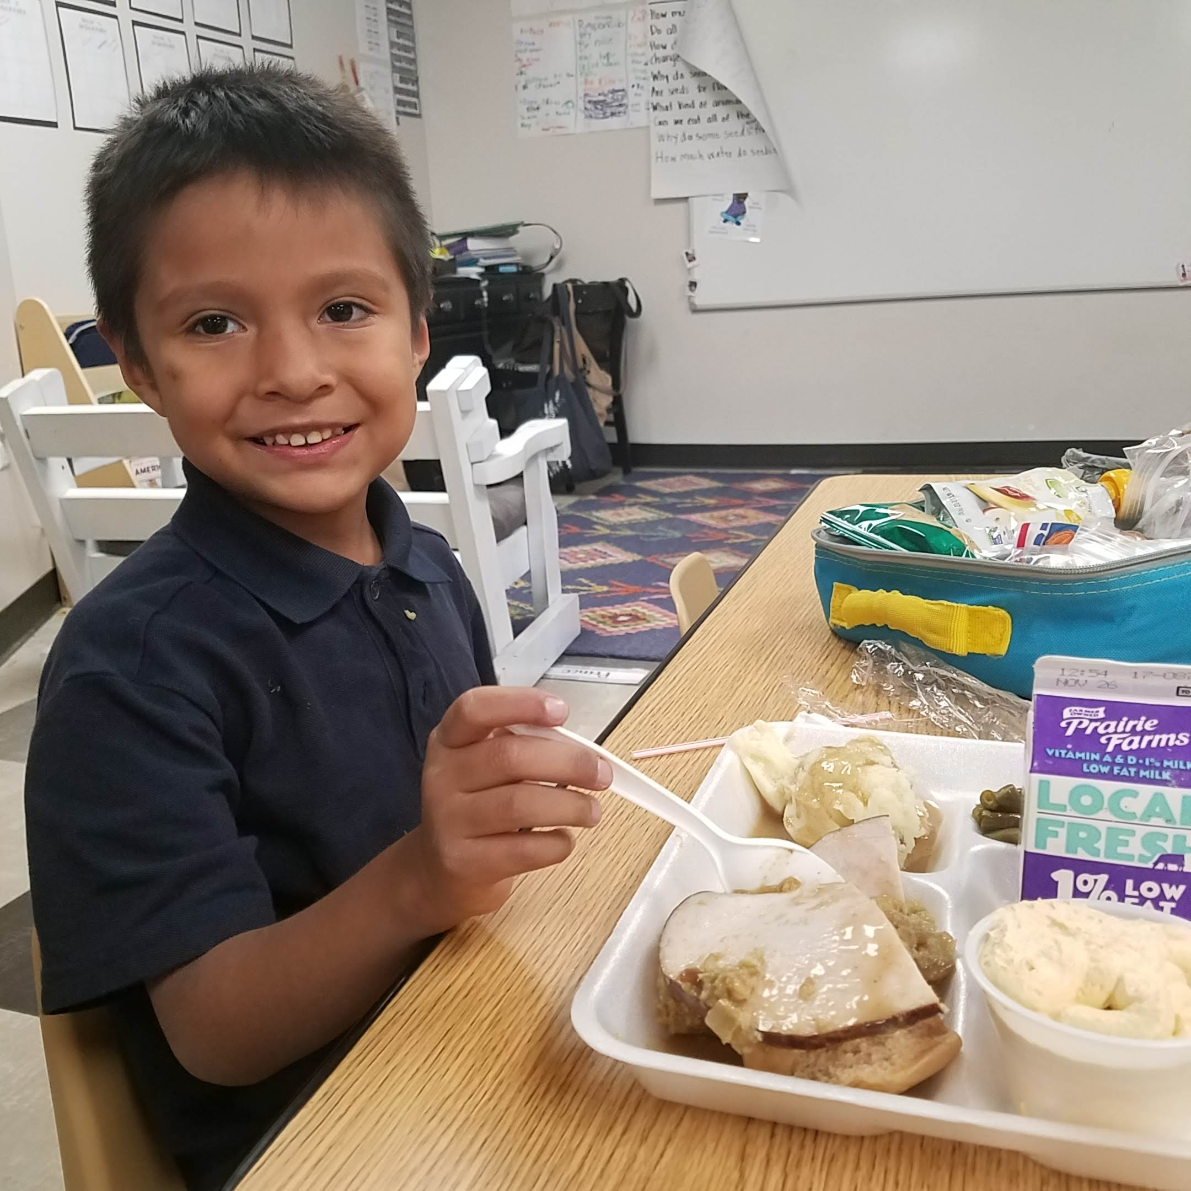
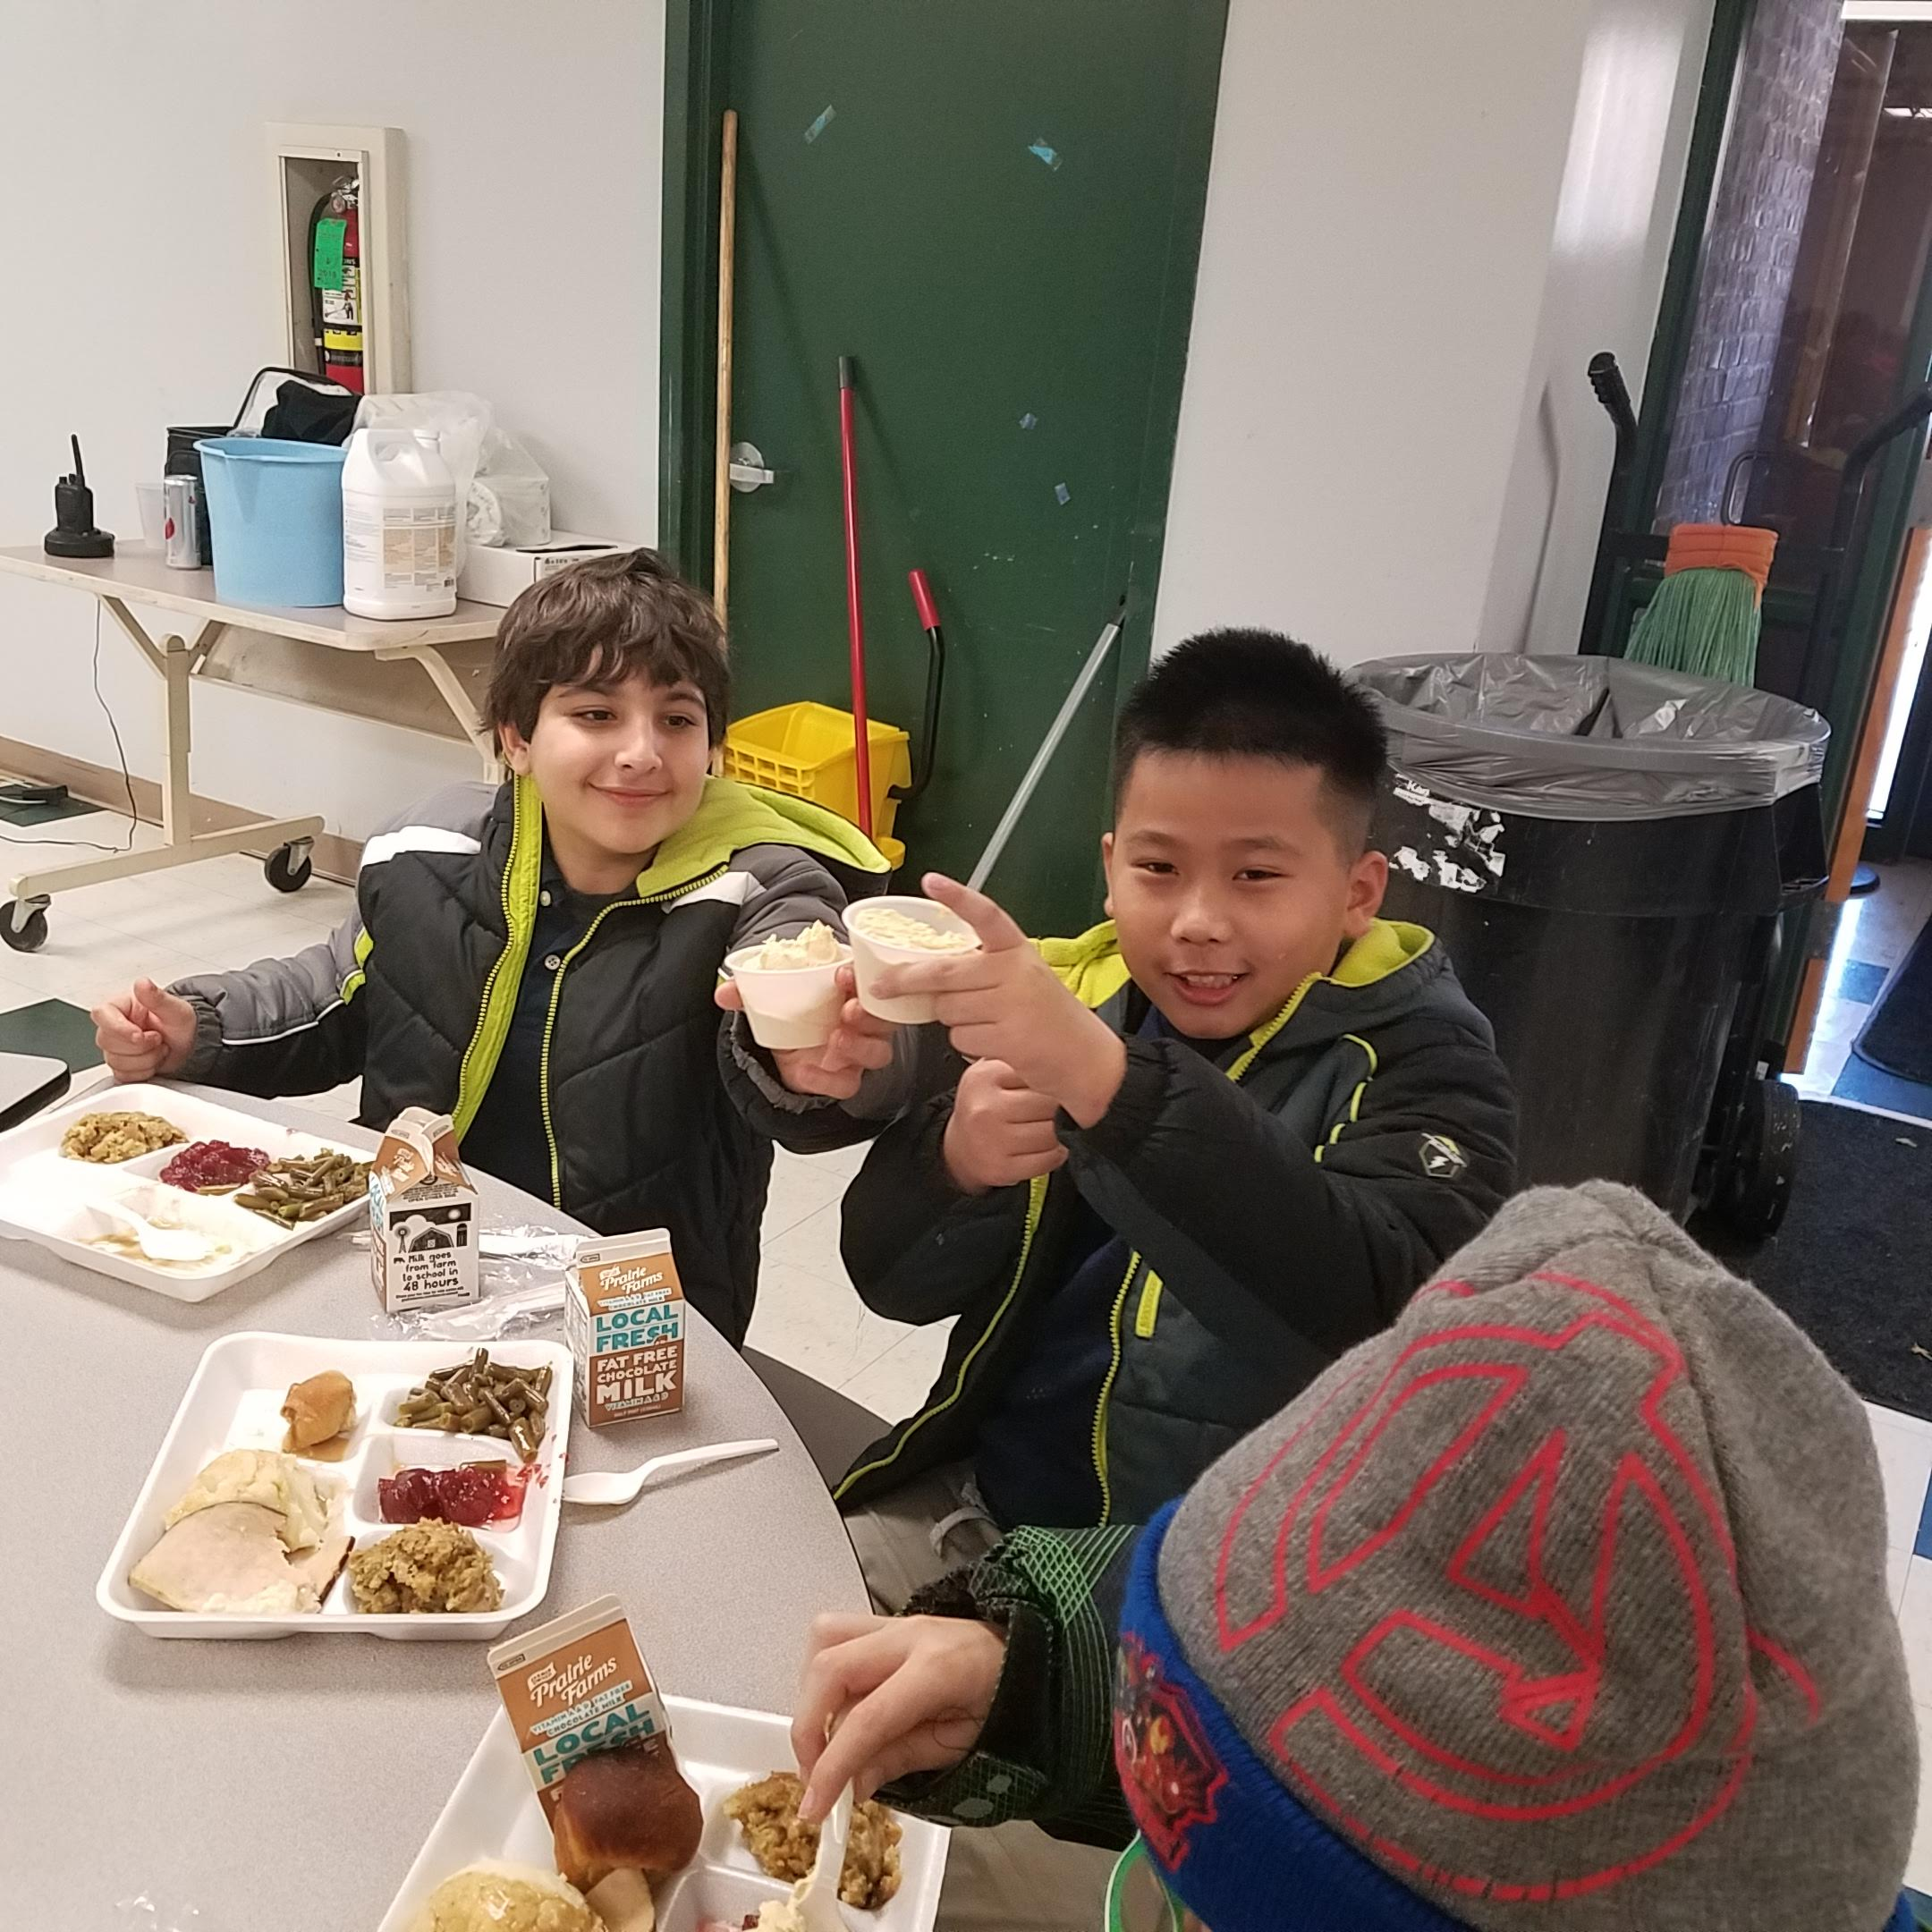

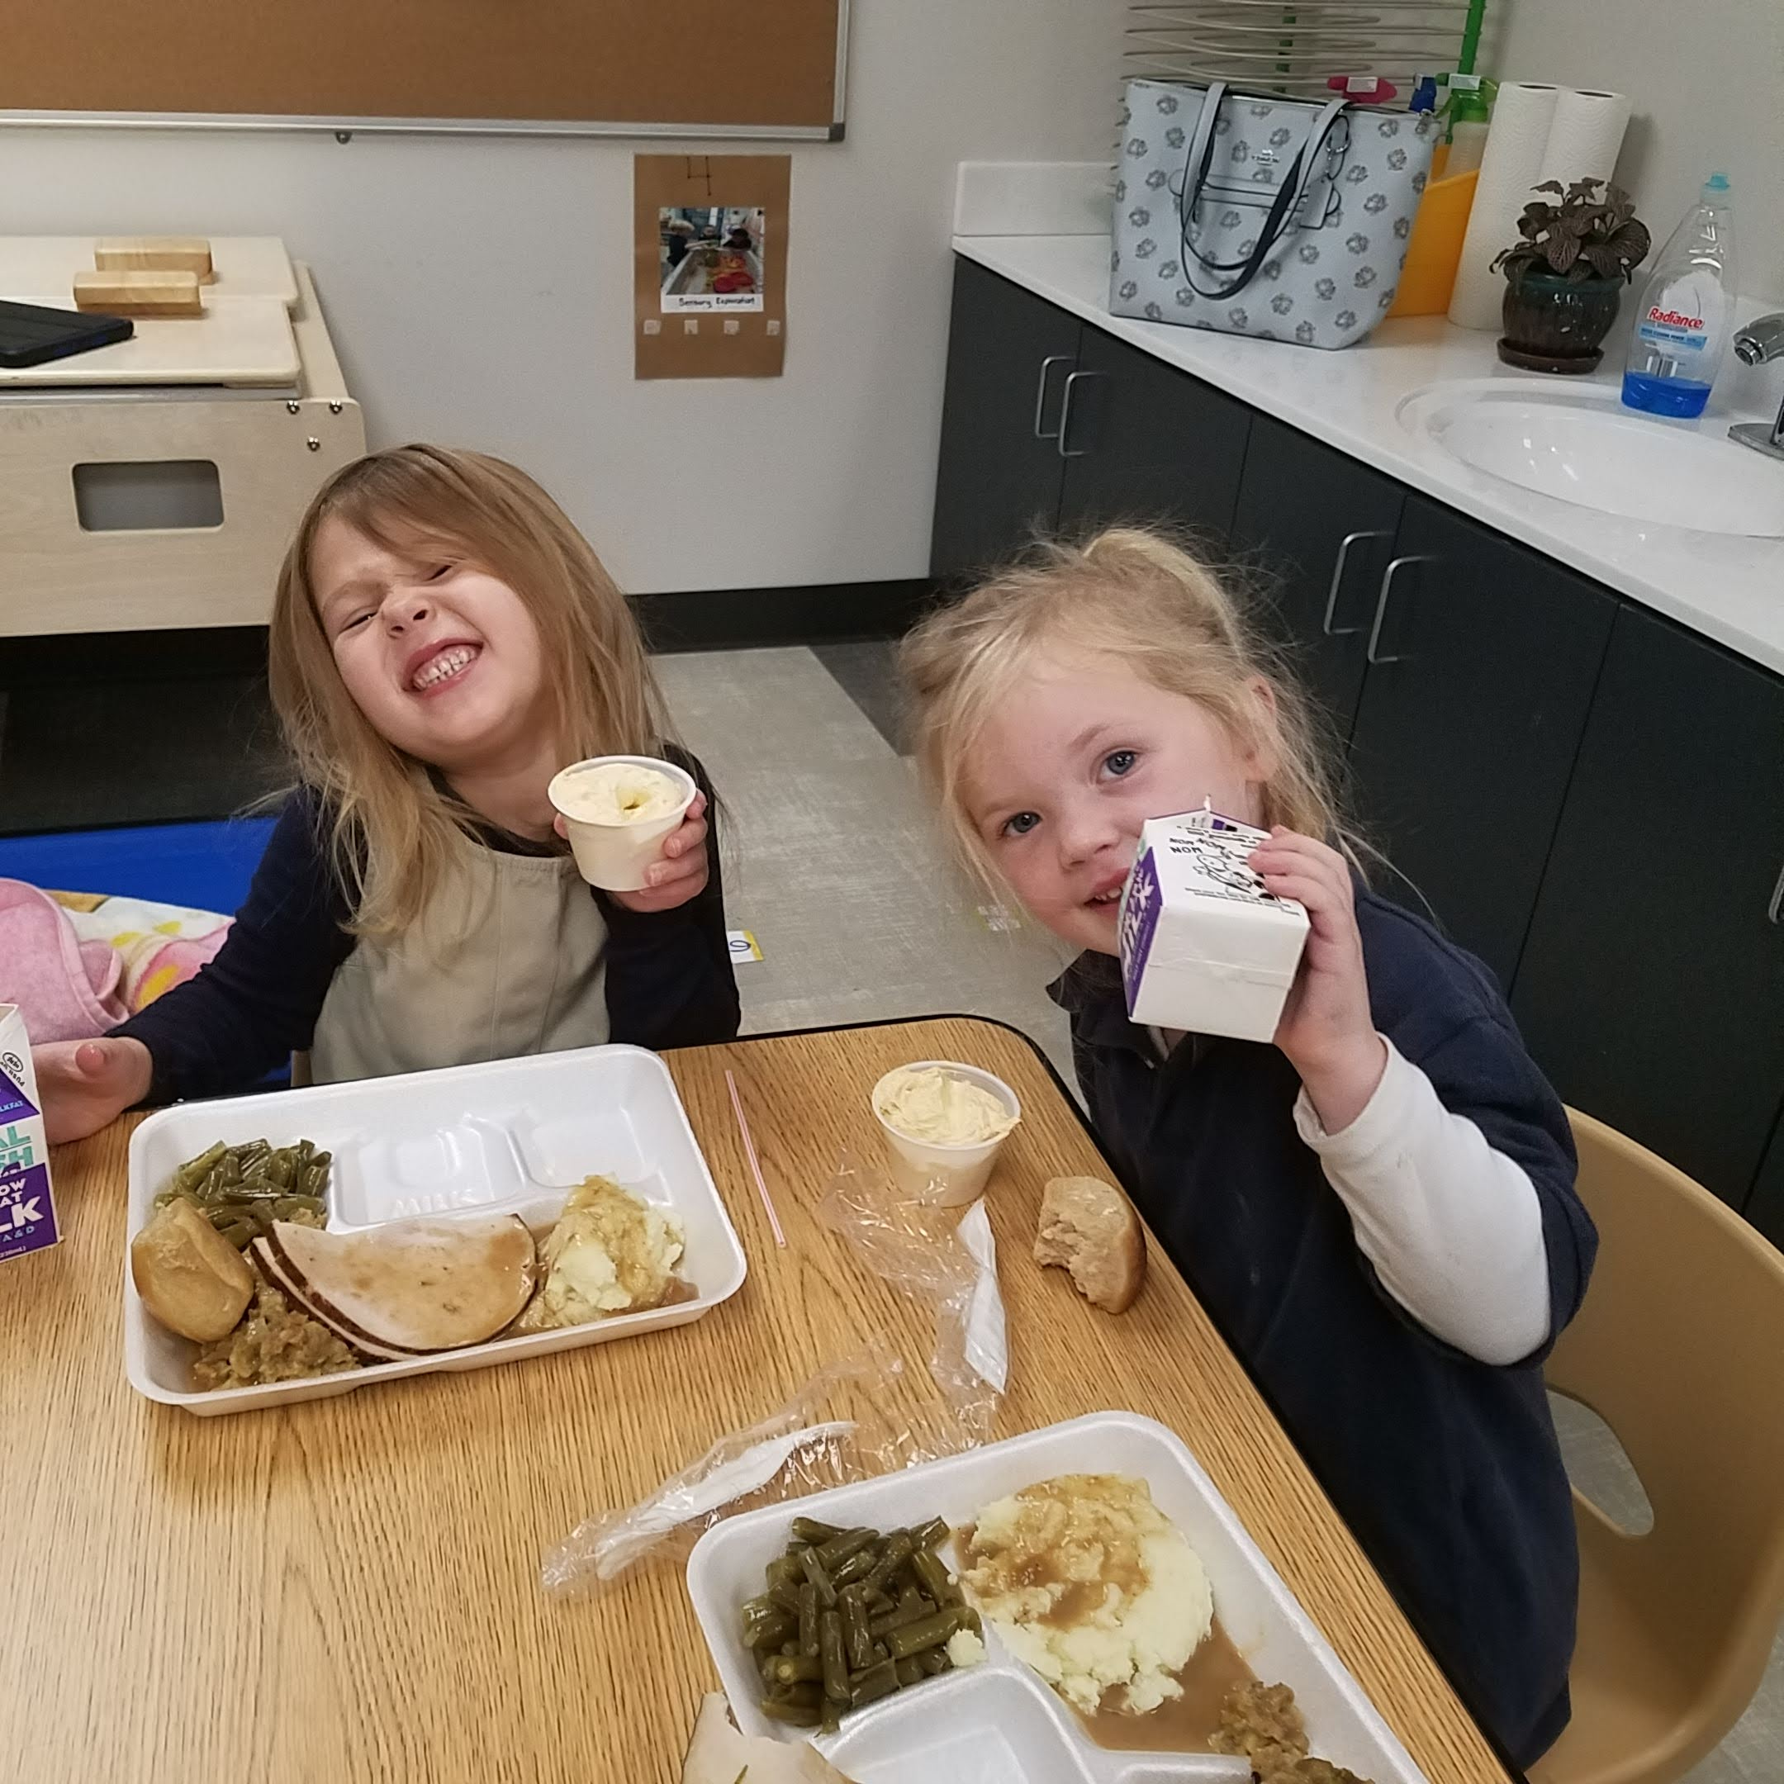

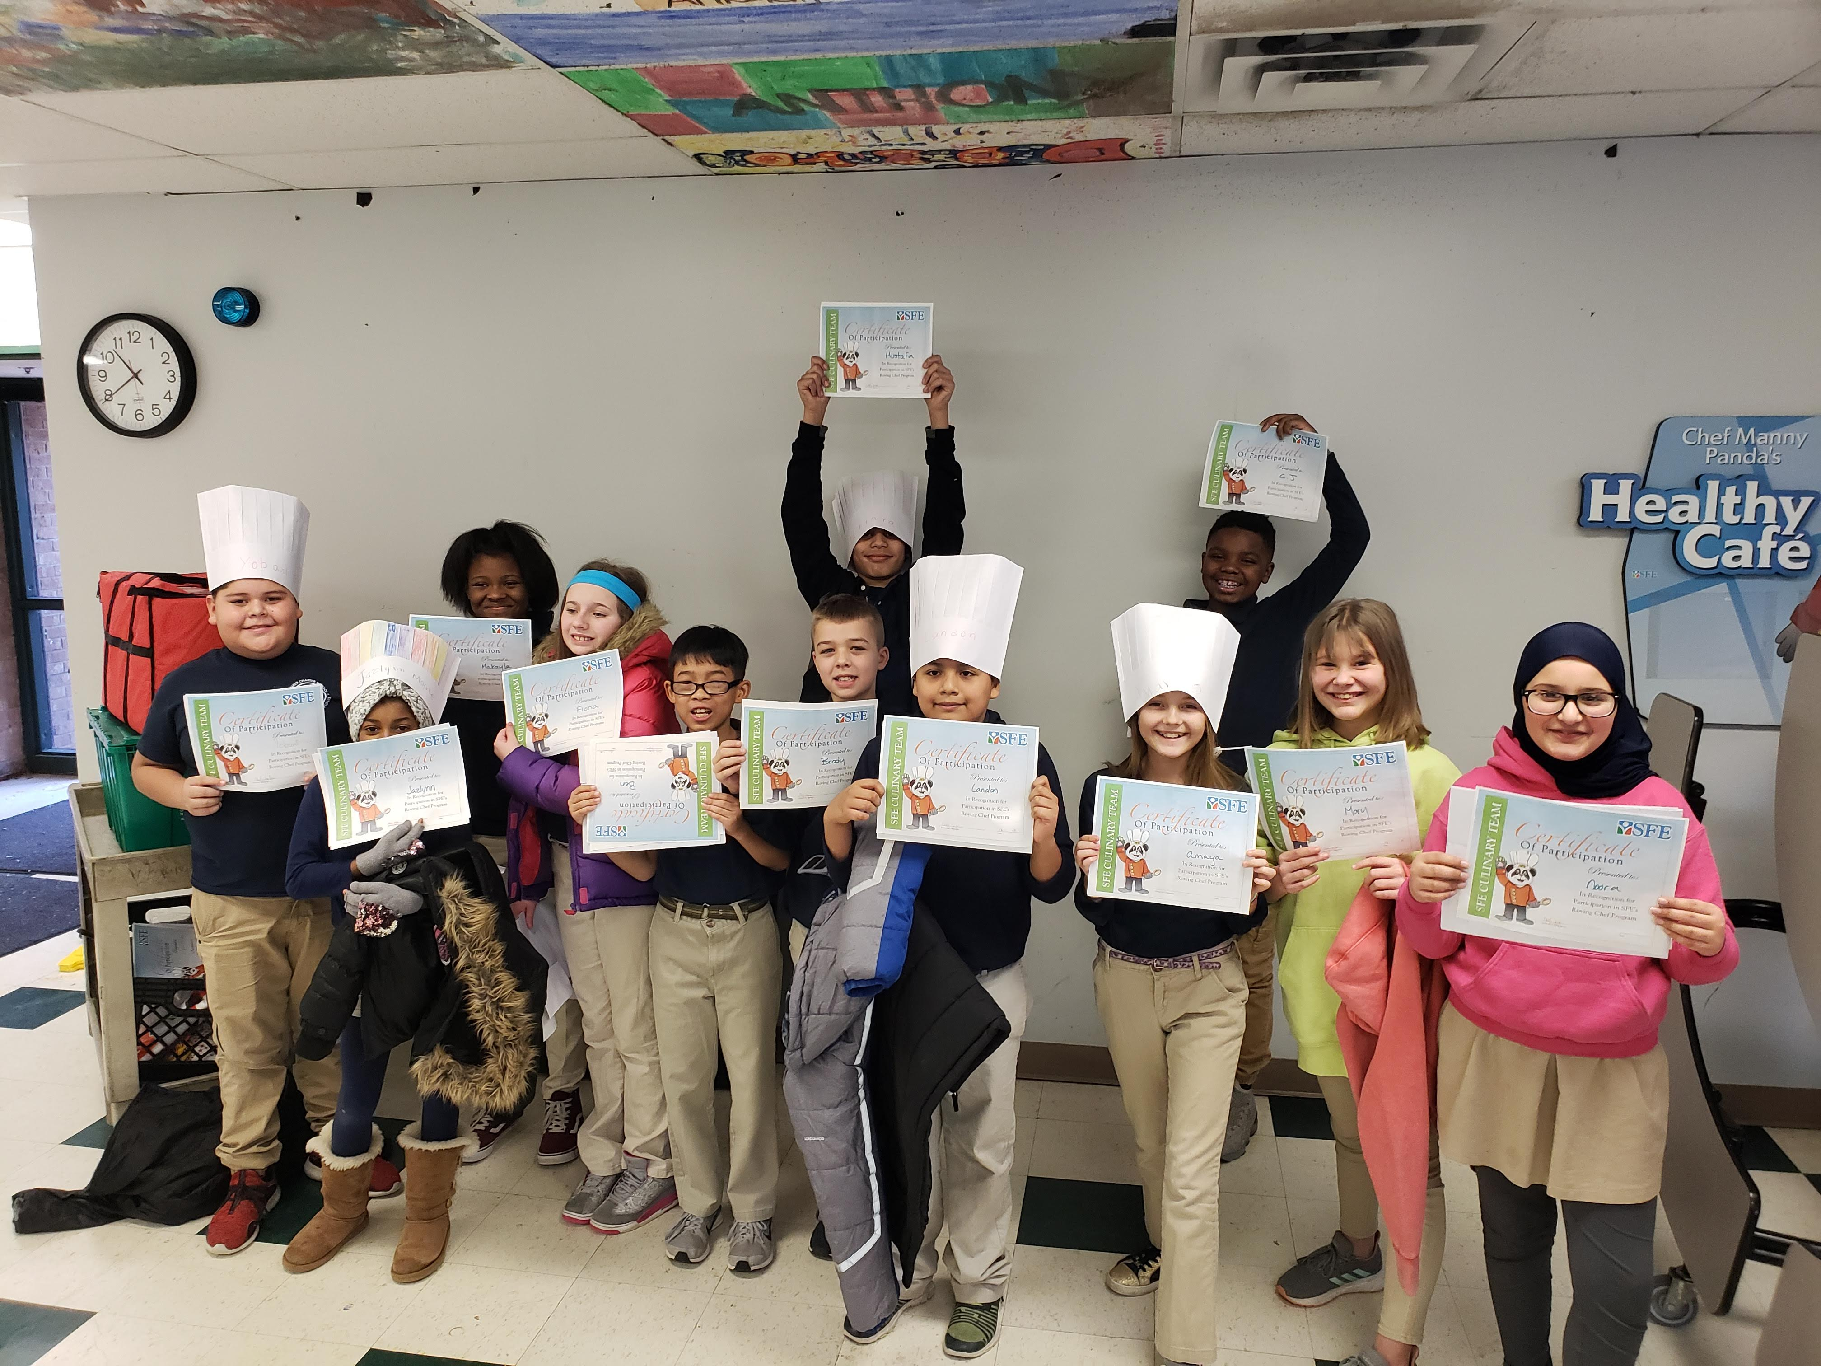
Roving Chef
Southwest Foodservice Excellence, LLC ~ “Putting Child Nutrition First”

